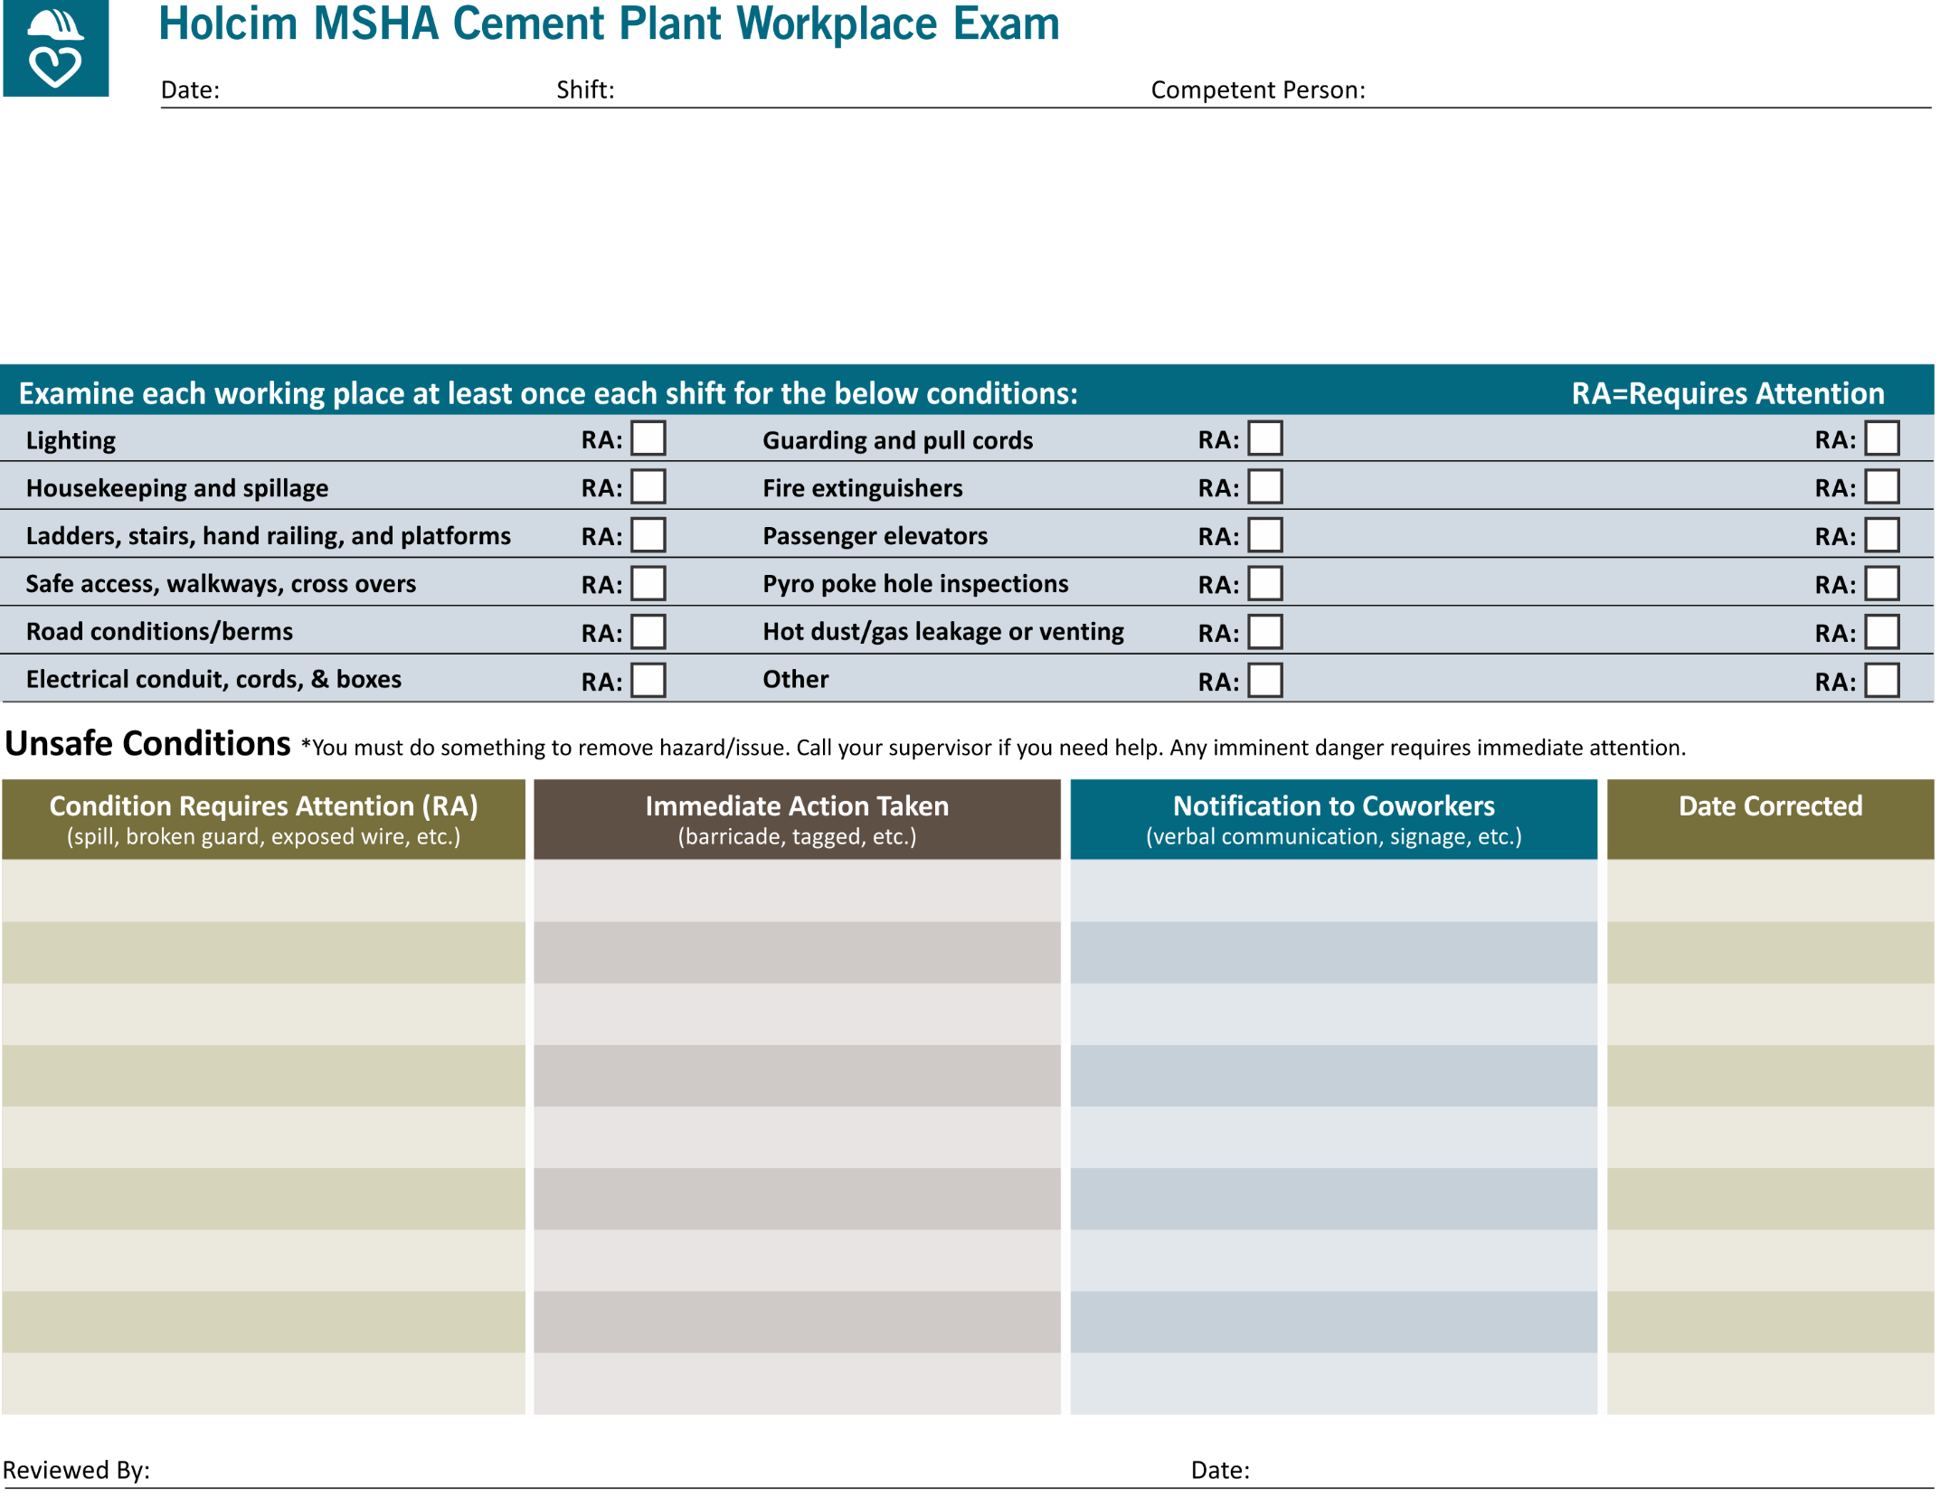

|  |  |  |  |  |  |
| --- | --- | --- | --- | --- | --- |
| **⃝ Quarry**  **⃝ Beltline**  **⃝ Frog Pond/Piles** | **⃝ Mill Building**  **⃝ Raw Silos/6th Floor**  **⃝ Loader Travel Area** | **⃝ Pack house**  **⃝ Shipping Silos**  **⃝ Rail Area** | **⃝ Kiln & Clinker Cooler**  **⃝ Coal Mill & Feed**  **⃝ Preheater Tower** | **⃝ Geocycle**  **⃝ Maint Shop**  **⃝ Day Repair** | **⃝ Warehouse**  **⃝ Machine Shop**  **⃝ QC Lab** |
| **⃝ Other:** | | | | | |

**Trash Cans**

**Oil Spills/Leaks**

**Air Hose Clips**

**Gas Cylinders**

**Eye Wash**

**Chemical Storage**